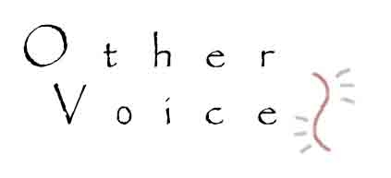
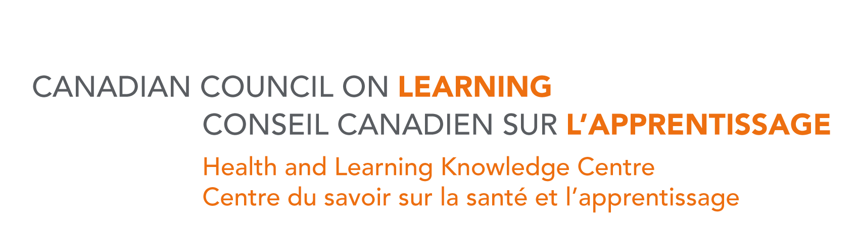

Second Annual Other Voices Forum
October 19th, 2007
World Trade and Convention Centre,
1800 Argyle Street, Halifax, NS, (902) 421-8686

The second annual Other Voices Forum will be held at the World Trade and Convention Centre, Halifax, Nova Scotia on Friday, October 19, 2007.

Co-sponsored by the Other Voices Working Group and the Canadian Council on Learning’s Health and Learning Knowledge Centre, this event offers a unique opportunity to hear from a range of marginalized Canadians on their experience with barriers to health and learning.

Introduction: Douglas Hodgkinson, Director Strategic Initiatives and Knowledge Exchange
Keynote Speakers: Lauren Casey, Co-ordinator, Canadian National Coalition of Experiential Women and
Prior Learning Assessment Centre – to be announced.

Over 20 people with direct experience in poverty, homelessness, sex-work, addiction, low literacy and mental health issues will be presenting on topics such as:

- the urgency and importance of the needs of groups that are at risk and/or demonstrably below the acceptable standards of health in Canada;
- the importance and role of insider knowledge and the value of lived experience in the knowledge and policy development and knowledge exchange process;
- the incorporation of grassroots community involvement in research by supporting the capacity of community groups and programs;
- transformation through knowledge exchange; and
- research on exemplary practices, demonstration projects and involvement of practitioners and community members.

This forum is of interest to policy makers, researchers, government officials, academics, community organizations and service providers,

To register: As space is limited, please reserve by completing and sending the registration form by email or fax to Barbara Smith at barbjsmith@shaw.ca or (250) 388-5324 (fax). For additional information please call (250) 388-7940 or (250) 920-9225.

To view last years forum report go to: http://www.ccl-cca.ca/NR/rdonlyres/C0775A78-C674-41F5-9463-0E8E2DF64087/0/TRA07VP017OtherVoicesForumHLKCNewsletter.pdf

Registration Form
Other Voices Forum
October 19th, 2007
World Trade and Convention Centre, 1800 Argyle Street, Halifax, Nova Scotia

Please complete this forum registration form and return it by fax or email.

Other Voices Forum
barbjsmith@shaw.ca
Fax (250) 388-5324
Tel (250) 920-9225
Tel (250) 388-7940

Name: _________________________________________________________________________

Organization: ____________________________________________________________

Mailing Address: ___________________________________________________________________

Telephone: ( ) __________________________________________________________

Email: _______________________________________________________________________

I hereby give permission for my name, email and mailing address and telephone number to be published as part of a participants list for the forum. yes No

Lunch will be provided and will include a selection of special options for people with allergies and other special requests.

Please indicate if you have special food requirements so that we can order an appropriate number of selections.

________________________________________________________________________

Registration Fee:
There is NO CHARGE for this forum.

Accommodation
There are rooms blocked for October 18 and 19, 2007 at the Delta Barrington Hotel. It offers a government and university rate of $155.00 for a suite. To reserve a room at this hotel, please contact them directly at 1-800-661-8870 and ask for the ‘Other Voices Forum’, Canadian Council on Learning.

